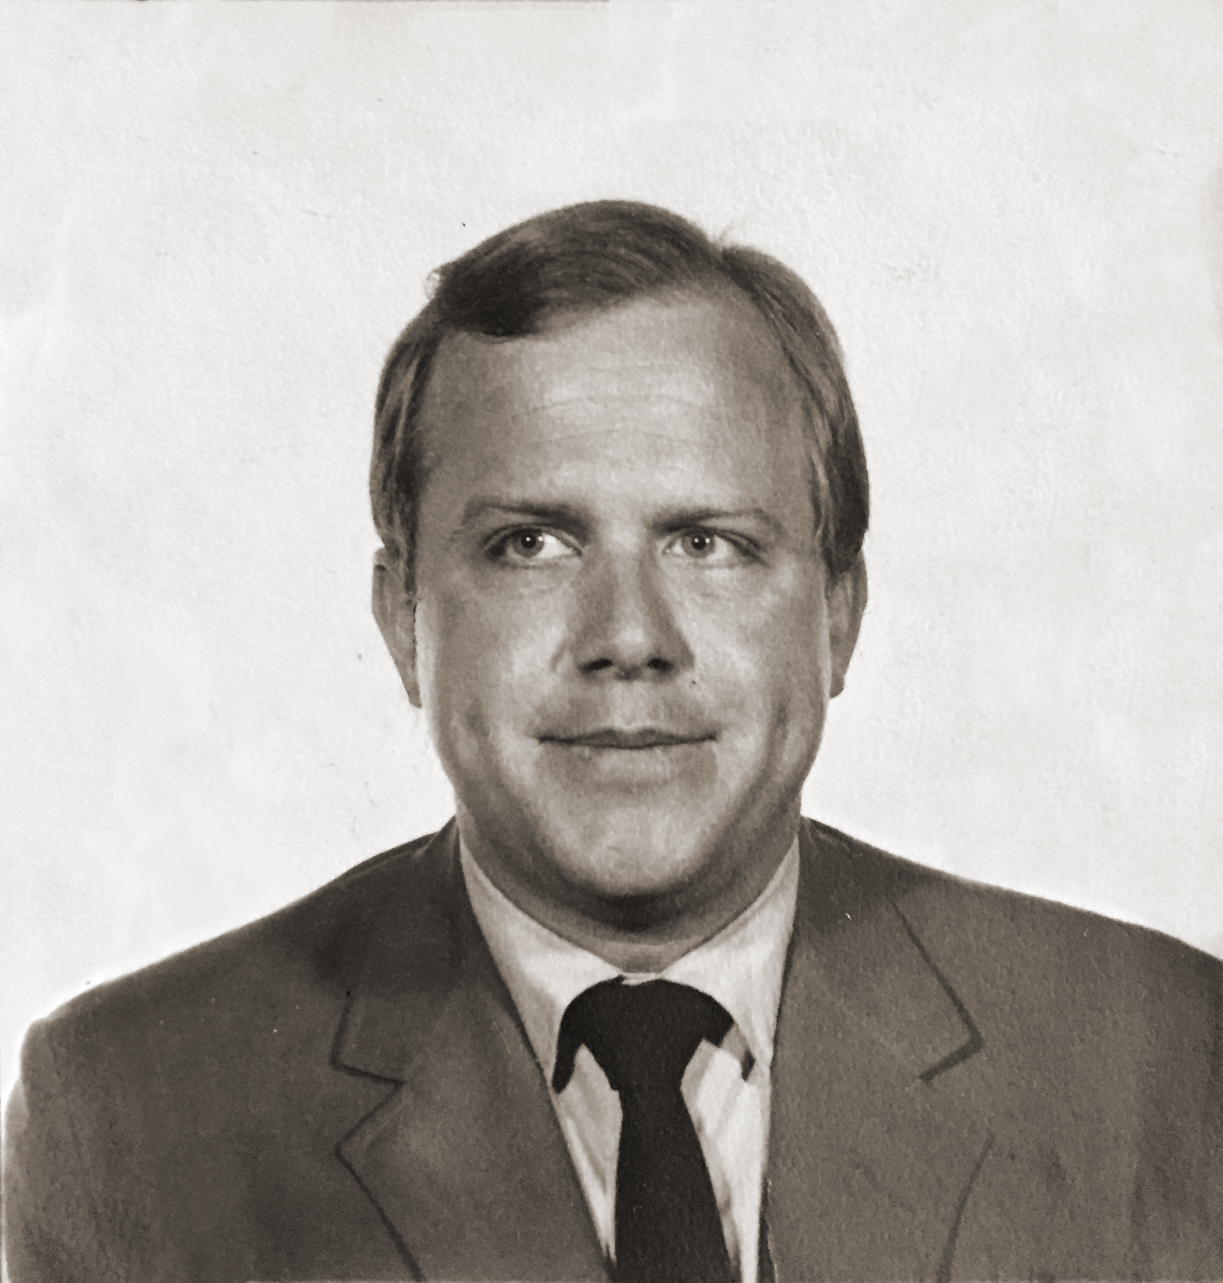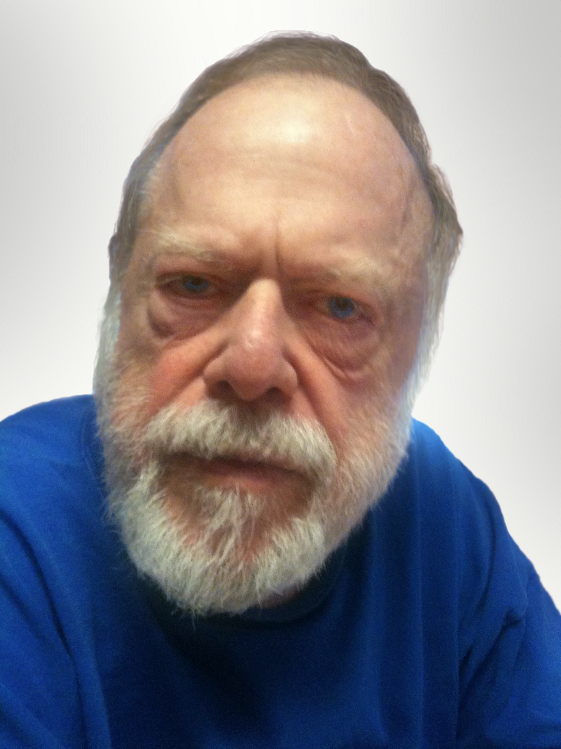
Sammy Jo Stewman died in Houston, Texas on August 25, 2015. Sam was born on August 9, 1942 to Arch and Eunice Stewman in Mena Arkansas. He graduated with a Bachelor of Arts from the University of Arkansas in 1964 and studied in Germany on a Rotary Fellowship the following year. He received a Masters degree in German literature from the University of Colorado and went on to teach German and Spanish at Eastern Oklahoma State College. He was a Co-founder of the Community Resale Shop in Houston, the first and only resale shop that catered to people with AIDS and homeless Veterans. After losing his sight, Sam became an advocate for safer streets for the blind. He taught English as a Second Language at Houston Community College and was a longtime PFLAG member. When he could no longer volunteer he would recruit others to help. Sam was fiercely independent, had a sharp sense of humor and in death, as in life, he continued his tradition of generosity by donating his body to science.

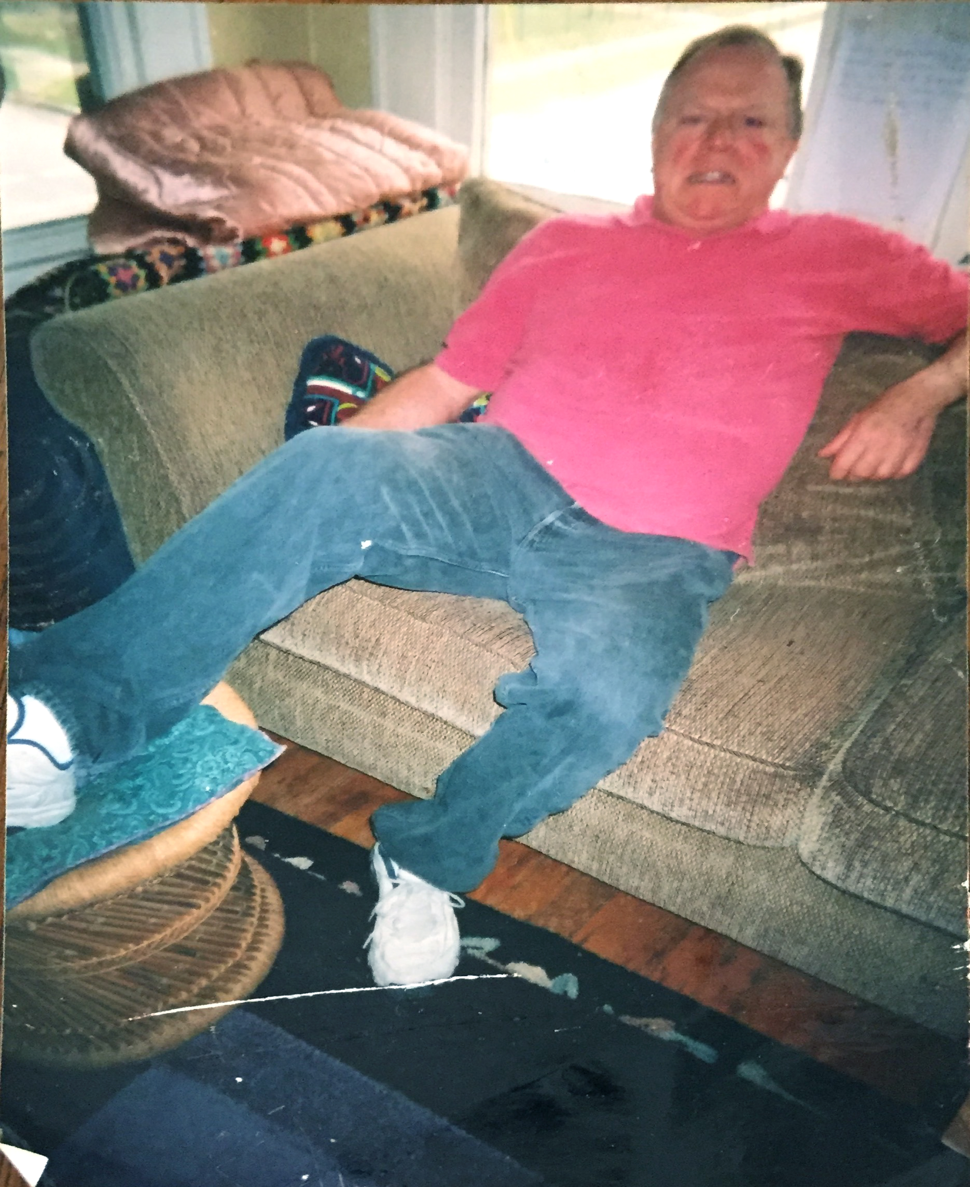
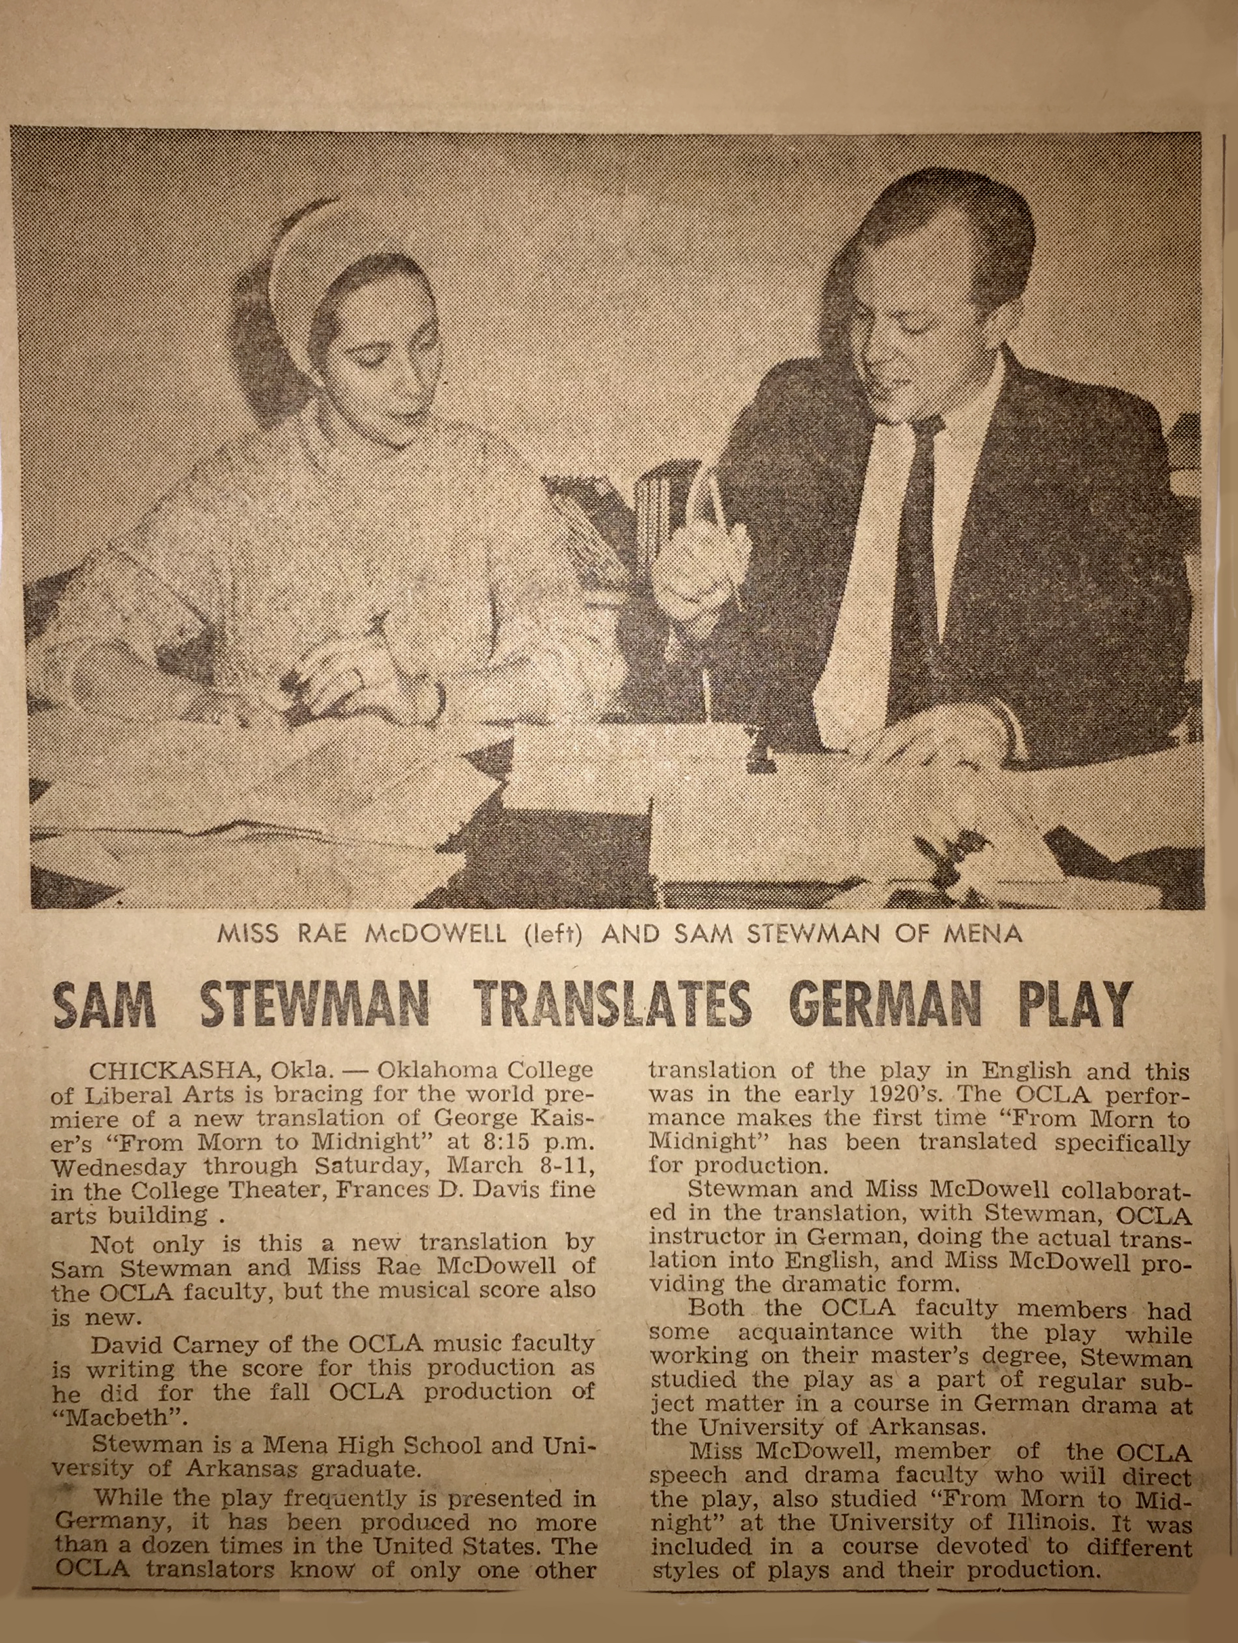

FROM SAM STEWMAN’S FILES (in random order)

TREAT WITHOUT RETREAT

Dedicated to a host of caregivers whose worth is beyond measure, and to one medical doctor whose name has been (carefully) forgotten.

I WILL GO WHERE I NEED TO GO, AND I WILL BE WHERE I NEED TO BE.
I SAID THAT I WOULD, AND I WILL.
I SAID THAT I DO, AND I SHALL.
YES, I AM AFRAID AND DISMAYED, TERRIBLY TORN AND TIRED,
BUT, I SAID I WOULD AND I WILL.

IT’S MY JOB. I WILL TREAT WITHOUT RETREAT.
IT’S MY JOB AND NOT ALWAYS LIGHT AND SWEET.
I SAID THAT I WOULD, AND I WILL.
I SAID THAT I DO, AND I SHALL.

I HAVE MADE A VOW TO HEAL AND WITH ALL THAT IS WITHIN ME,
I SAID THAT I WOULD AND I SHALL.

NO SONGS OF SORROW

SING NO SAD, SWEET SONGS OF SORROW
THERE’S TIME ENOUGH FOR THAT TOMORROW.
COME INSTEAD AND HOLD MY HAND,
SPEAK OF PLEASURES PAST AND PLANNED.
FOR MOMENTS FEW ARE MOMENTS GOLD,
AND WHAT WE GIVE IS ALL WE HOLD.

TIME

WHEN I WAS A CHILD THERE WAS TIME TO SPARE
TO WATCH THE GRASS GROW,
TO FEEL THE WIND BLOW,
TO LET THE CLOUDS FLOW,
WHEN I WAS A CHILD THERE WAS TIME TO SPARE

NOW I GUARD EACH GRAIN OF TIME LIKE GOLD,
BUT I WATCH THE GRASS GROW,
AND FEEL THE WIND BLOW,
AND LET THE CLOUDS FLOW.
I GUARD EACH GRAIN OF TIME LIKE GOLD.

ONE AND ONE

ONE AND ONE, BUT MORE THAN TWO,
I’M ONLY ME; YOU’RE ONLY YOU.
WE’RE ONE AND ONE BUT SOMEHOW MORE THAN TWO.

BECAUSE JUST ONE SOFT WORD
FROM YOUR SWEET LIPS,
THE PAIN IS GONE,
THE ACHING QUITS.

YOUR PRECIOUS SMILE
MAKES MY LIFE WORTHWHILE,
WE’RE ONE AND ONE
BUT, SOMEHOW, MORE THAN TWO.

PET HAIKU-ESQUE POETRY

“MEOW,” SAYS THE CAT.
“NOW” IS WHAT HE REALLY MEANS.
DEMANDING FUR BALL.

“RUFF,” SAYS THE POOR DOG.
“TAKE ME FOR A WALK OR ELSE.”
DEMANDING FUR BALL.

JUST ON MY PILLOWS,
SMILING UP AS IF HE KNOWS.
MORE THAN A MAN’S BEST FRIEND.

Reflections on AIDS experiences

A slightly confused ninety-year-old woman from Humble was at the funeral of her grandnephew. She asked why he died so young. She was told and this is basically her reply.

THESE THINGS I’VE HEARD ON T.V.
THEY’RE QUITE A MYSTERY TO ME.
I’VE HAD AIDS TWENTY YEARS,
IN BOTH OF MY EARS,
AND WEARING THEM HASN’T HURT ME.

I CRIED. (IT’S BEEN TWO WEEKS, AND I HAVEN’T DIED YET.)

THEY SAID TO GO HOME AND GET READY TO DIE.
I DID WHAT THEY SAID. BUT I THINK IT’S A LIE.
I’M NOT ANY WORSE,
SO DON’T CALL THE HEARSE.
I THINK THAT I MAY BE JUST READY TO LIVE.

“Such a very handsome man,” she’d say,
“Long eyelashes fit for a queen,
What can I do
to have them like you?
They’re the longest that I’ve ever seen.”

They’re all my own, you silly twit,
But weren’t always what you see.
They’ve grown this way
Since the miserable day
When I started taking AZT.

Leroy died two days after his grandmother died. Don died trying to work. His wife was HIV negative.

FOR MY FRIENDS

I first met Dan and Mike about ten years ago.

Mike was a big, bright, happy Italian-American. Mike has been dead about a year now. His last year was filled with hope and dashed dreams.

PNEUMOSISTIS, S.S.I., A.Z.T.
SOCIAL WORKERS, D.D.I., C.M.V.
BUT FRIENDS STILL CARE
AND GRASS GROWS GREEN
AND CLOUDS ROLL BY,
AND LOVE IS STILL THE KEY.

Dan seemed permanently healthy. He was solid, hard, and immeasurably bright. He bought his body with hours in the gym. He bought his Porsches with the spoils of working smart. Extra money in what should be early middle age is now, at best, small comfort.
For the Caregivers:

Pneumosistis, S.S.I., A.Z.T.
Social workers, D.D.I., C.M.V.
But friends still care
And grass grows green
And clouds roll by,
And love is still the key.

EINSTEIN THE CAT SNARLS AT GONK, THE DOG:

CAN’T YOU SEE I’M ALL A-TWITCH?
ON YOUR WAY YOU SILLY BITCH!
DON’T YOU KNOW YOU’RE IN MY SPACE!
FIND YOURSELF ANOTHER PLACE!

HOW COULD I EVER CATCH MY PREY?
MESS WITH ME, AND THERE’S HELL TO PAY!
MUST YOU PUT YOUR LIFE IN DANGER?
GOING SO SOON? DON’T BE A STRANGER.

FOR GONK

I KNOW; I KNOW; I KNOW.
I KNOW THAT I MUST GO,
AND YOU WILL STAY BEHIND.

I CRY; I CRY’ I CRY
AS EVERY DAY GOES BY.
WHAT NEW HOME WILL YOU FIND?

I HOPE; I HOPE; I HOPE.
AND KNOW THAT YOU WILL COPE
AS OTHERS HAVE BEFORE.

BLACK AND WHITE, THE CAT

LIFE IS SIMPLE
LIFE IS SAFE.
LIFE IS SWEET.

SURE, THERE’S THAT PLACE
WHERE PEOPLE TOUCH
AND STING
AND POKE YOU,
BUT THAT WAS LONG AGO AND FAR AWAY.
SEEN ANY MICE LATELY?

WILL THEY LOVE THEM AS MUCH AS I DO?

THESE BALLS FO FUR SO DEARLY LOVED, WHO AT MY FEET HAVE PLAYED,
I NOW MUST LEAVE TO OTHERS’ CHARGE, AND WHEN THE PAIN IS WEIGHED,
IT WILL BE THE FREATEST FAR, OF ALL THE PRICES PAID.

EINSTEIN , THE CAT GONK, THE DOG

CAN’T YOU SEE I’M ALL A-TWITCH.
ON YOUR WAY YOU SILLY BITCH.
DON’T YOU KNOW YOU’RE IN MY SPACE.
FIND YOURSELF ANOTHER PLACE.

HOW COULD I EVER CATCH MY PREY?
MESS WITH ME AND THERE’S HELL TO PAY.
MUST YOU PUT YOUR LIFE IN DANGER?
GOING SO SOON? DON’T BE A STRANGER.

CATS

SEEMS THOUSANDS OF CATS COME OUT EACH DAY
TO TAUNT THE DOG AND BLOCK THE WAY.
SOME ARE PRETTY, SOME ARE CUTE,
SOME NOD, “HELLO,” SOME SIT MUTE.

OUR FRIEND NEXT DOOR, THE MOTHER OF TEN,
IS HAPPY KNOWING IT WON’T HAPPEN AGAIN.
EINSTEIN, THE TERRIBLE, DARES US EACH DAY,
SAYING IT WOULD BE BETTER TO GO SOME OTHER WAY.

BUT THE PRETTIEST OF ALL, THE QUEEN OF THE MAY,
PEER THROUGH A FOG AND SEEM NEARLY TO SAY,
“YOU COULD BEND DOWN AND STROKE US.”
BUT SHE’S JUST FAR TOO GOOD LOOKING TO FOCUS.
TEARS OF SORROW NEVER CEASING

TEARS OF SORROW NEVER CEASING, THROUGH THE PAIN AND LOVE INCREASING, ARE GIVEN ME TOO SOON.

WHY?

WHY? WHY? WHY? WHY NOT?
WHEN? WHEN? WHEN? NOT YET.
WHERE? WHERE? PLEASE, NOT HERE.
WHO? WHO? WHO? ME.
NOT ME. NOT ME. NOT ME.
WHY NOT?

TIME

DON’T STEAL MY TIME; IT’S NOW IN SHORT SUPPLY.
DON’T WASTE MY TIME; I’M TOLD I SOON WILL DIE.

IT’S THEM NOT ME

IT’S THEM NOT ME. HOW SAD TO SEE.
IT’S THEM NOT ME; WHAT WILL BE, WILL BE.
IT CAN’T BE ME. IT CAN’T BE ME.
IT’S JUST NOT ME; OH CAN’T YOU SEE?

BUT IT IS ME, AND IT’S MINE.
I HOPE IT IS TRUE THAT FIRES REFINE.
THE CHOICES NOW ARE SO UNKIND.

GET ON WITH YOUR LIFE (WITH APOLOGIES TO GIVE ME BACK MY SHILLING)

GET ON WITH YOUR LIVING; GET ON WITH YOUR LIFE.
YOU CAN STAND ON YOUR OWN FEET NOW; GET ON WITH YOUR LIFE.
AND YOU HOLLER WHY, AND YOU HOLLER WHY.
YOU CAN STAND ON YOUR OWN FEET STILL;
GET ON WITH YOUR LIFE.

GET ON WITH YOUR LIVING, GET ON WITH YOUR STRIFE.
YOU CAN STAND ON YOUR OWN FEET STILL; AND IT’S STILL YOUR LIFE.
AND YOU HOLLER WHY, AND YOU HOLLER WHY.
YOU CAN STAND ON YOUR OWN FEET STILL;
GET ON WITH YOUR LIFE.

BRIGHT SUNSHINE, GLORIOUS DAY

IT’S A DAY OF BRIGHT SUNSHINE. WHAT A GLORIOUS DAY!
IF YOU WERE BUYING THIS DAY, WHAT WOULD YOU PAY?
IF YOUR HEART DOESN’T SING, AND YOU SPIRIT TAKE WING,
THEN YOU’RE WASTING YOUR SPACE. PUT A SMILE ON YOUR FACE.

Haiku-esque efforts:

Leaves lightly blowing
Trees standing stately saying
WE WILL REMEMBER

From all those who care,
Looks of unending patience
I will take with me.

“Meow,” says the cat.
“Now” is what he really means.
demanding fur ball.

“Ruff,” says the poor dog.
“take me for a walk or else.”
demanding fur ball.

Retirement unasked.
Time to sit alone and think.
I lived and I died.

Love incarnate here
In people who do not ask.
Makes my poor heart sing.

Simple becomes the best.
Money loses its power.
A new perspective.

Just on MY pillows,
Smiling up as if he knows.
More than a man’s best friend.

Worshipping the clock,
We hurry through our young lives.
With age we repent.

Shards

The shards of promises breaking
Pile higher with each new day.
As dread and fears are waking.

BEEN THERE

Been there. Done that.
Would do it all over again.
And this is the advice I have for you:

You can sit and cry and wonder why
Life’s treated you so badly.

Or you can seize the day and get under way,
And live life just as you should have anyway.

You can pitch and moan and carry on,
And say life’s ending quite sadly.

Or you can seize the day and get under way,
And live life just as you should have anyway.

You can drink and fight and stay out all night
And wonder why you feel so wretched.

Or you can seize the day and get under way,
And live life just as you should have anyway.

Don’t dull the end. Treat it like a good friend.
And ease the way for those who stay.

Or you can seize the day and get under way,
And live life better than you would have anyway.

My Two Cats

My other cat could levitate.
I swear; I swear; I swear.
I saw him go from Down to Up
And never move a hair.

But THIS poor creature!

Like any cat,
He tries to jump,
But when he lands
You can feel the thump.

COME WALK WITH ME

Come, walk with me through the shade of the glen,
as my evening fades, and this journey ends.
We’ll talk again of all that was good
And laugh at the things we’d change if we could.

When I am gone,
You won’t be alone.
I’ll come again
to the shade of the glen.

Then, waltz with me through the shade of the glen.
Where life is sweet and all hurting ends.
Then, think again of all that is good
And know I am there in the shade of the woods.

So, please, come walk with me
through the shade of the glen.
For my evening fades,
And this journey ends.

ANGELS

They say angels have wings, but we have them too.
My newest pair, I got them from you.
You stood by me and said that I could.
Damned if I didn’t, and I’m pretty good.

With new wings unfurled, I soar, and I spin
Knowing you’re there each time I in.
Without all your help and knowing you cared,
I might never have dreamed and never have dared.

(With apologies to Bartlett’s. Perhaps not too familiar?)
LOVE IS YOU BY ME 1964

LOVE IS A ROSE IN THE MORNING DEW;
LOVE IS YOU BY ME WHEN FRIENDS ARE FEW.
LOVE IS A PRETTY, PRETTY THING;
LOVE IS YOU BY ME WEARING MY RING.
LOVE IS A FIRE BURNING THROUGH THE NIGHT;
IT’S YOU BY ME WHEN THINGS GO RIGHT.
AND WHEN OUR DAYS ON EARTH ARE DONE,
LOVE IS YOU BY ME WALKING TOWARD THE SUN.

I’VE GOTTA

I GOTTA STOP ALL THE BAD STUFF.
IT MIGHT HELP; IT COULD HELP; IT WOULD HELP; IT SHOULD HELP.
I GOTTA STOP ALL THE BAD STUFF.

I GOTTA START ALL THE GOOD STUFF.
IT MIGHT HELP; IT COULD HELP; IT WOULD HELP; IT SHOULD HELP.
I’VE GOTTA START ALL THE GOOD STUFF.

I GOTTA GO TAKE MY PILLS.
IT MIGHT HELP; IT COULD HELP; IT WOULD HELP; IT SHOULD HELP.
I GOTTA GO TAKE MY PILLS.

I GOTTA GO BY THE CLINIC.
IT MIGHT HELP; IT COULD HELP; IT WOULD HELP; IT SHOULD HELP.
I GOTTA GO TO THE CLINIC.

SMALLER HOPES AND DREAMS (This is the one I don’t want to screw up.)

HOW (Mother poem, unfinished)

HOW DO I TELL OF THE FINEST PART OF ALL THAT I AM MADE OF?
WHAT WONDER LIES AT THE VERY HEART OF ALL THAT HAS FORMED ME?

DO WHAT CHA MOMMA TOLD YA TO DO

DOWHATYOURMOMMATOLDYATODODOWHATYOURMOMMATOLDYATODODOWHATYOURMOMMATOLDYATODO ETC (UNDERLYING DRONE?)

EAT RIGHT; DON’T FIGHT.
STAND UP STRAIGHT; DON’T STAY OUR LATE.
NO BODIES THAT ARE LAZY. NO MINDS THAT ARE HAZY.
DO YOUR SHARE AND A LITTLE MORE.
DON’T SPEND YOUR MONEY ON A THANKLESS BORE.
TRY TO FIND THE GOLDEN MEAN. DIRTY LINEN SHOULD BE UNSEEN.
BE HAPPY WITH A SLOWER PACE. LEAVE THE WORLD A BETTER PLACE.
BUBBA

You say, “it ain’t me; it can’t happen.”
You say, “it’s just them.” That their time has come.
You say, “They deserve it. Watch god zap ‘em”
“It ain’t where I’m at, or I’m coming from .”

Well Bubba, that’s dumb.

There ain’t none of that stuff around here.
Them people’s weird; they’re all perverts.”
Well, you’ve known ‘em and loved ‘em for years:
Aunt Jane and her friends who never wore skirts.

And, Bubba that hurts.

What we do when we are drunk, it don’t matter.
We’re safe up here in the hills
From them big city ills
We just get stronger and bigger and badder.

Well, Bubba: Surprise.

WHACK

MADAM “DROOLLY” TOOK AN AXE.
GAVE OUR EGOS FORTY WHACKS.
WHEN WE SAW WHAT SHE HAD DONE,
MATY SAID, “LET’S HAVE SOME FUN.”

CROWED THE CRONE OF THY KINGDOM COME,
THIS SHRIEKING SHREW OF THEY WILL BE DONE:

“WE WANT NOTHING THAT DISTRACTS.
WE HAVE STANDARDS. THEY’RE NOT LAX.
DON’T CONFUSE ME WITH THE FACTS.
I’LL SHOW YOU MY PRETTY AXE.

SWEET JESUS SAVE ME (unfinished)

SWEET JESUS SAVE ME FROM YOUR DISCIPLES.
THEY SURROUND ME AT EVERY HAND.

OCTOBER 25, 1995

MCW

MAGIC AND MUSIC MEND MY MIND.
CASCADING CHORUS CENTERS MY SOUL.
WORRIES AND WORK WANE WITH WELL WOVEN WONDERS
OF MAGIC MUSIC.

SIMPLY AND SOFTLY SEINING SONGS, SAD AND SWEET
A STILL-JOLLY JESTER JUGGLES AND JABBERS THE GERMS OF VERSE.
STILL SEEKING SWEET SONGS TO SAY SADNESS SHOULD CEASE.
LET THERE BE MUSIC!

They come out of my ears, they come out my noses.
I’m sure if I wore them they’d come out of my hoses.
The silly rhymes and inane verses
Are, in themselves, their own kind of curses.
When the Muses hit, you have no recourses,
But to crank them out like a herd of wild horses.

Two men. One grocery cart.
Two lovers too soon torn apart.

Shoppers trying not to stare,
Reel in horror from the pair.
The one who surely has “the look”
Searches for something nice to cook
While those who are nearest look away,
Fearing most that dreadful day
When they may fill those shoes
And die a death they did not choose.

Two men. One grocery cart.
One man. One broken heart.
Zelda the Zealot pretty in pink,
Came to tell them what to think – nothing.
She came to tell them what to do.
She came to tell them (what) NOT to do – nothing.
And if they have a very short fuse,
What sort of protecting will they use – a prayer?

Pat, the preacher, like a missing link,
Came to show them what to think – nothing.
He came to show them how to now (to) love.
He came and told them not to love. – Nothing
And if they meet a terrible end,
They have to take what heaven will send – they deserve it.

Carol the kind, a happy tart,
Came with love deep in her heart – why not?
She came to show them that someone cared.
She came to show them that someone dared – why not?
And her small part plus many more,
Lie directly at the core – of worthwhile life among humans.

Susie the sweet, no fool she,
Learned the things that had to be – done over and over consistently.(I’ll finish with her later; millions more of these would be easy)

HOLD MY HAND

SING NO SAD, SWEET SONGS OF SORROW.
THER’S TIME ENOUGH FOR THAT TOMORROW.
COME INSTEAD AND HOLD MY HAND:
SPEAK OF PLEASURES PAST AND PLANNED,
FOR MOMENTS FEW
ARE MOMENTS GOLD.
ONLY WHAT WE FREELY GIVE
IS EVER OURS TO HOLD.
YOU WERE THERE

FROM THE VERY BEGINNING, YOU WERE THERE:
TO A TIME THAT HAS NO ENDING, YOU’LL BE THERE.
WHEN I NEEDED EXTRA SPINE, YOU WERE THERE.
WHEN THE FAULT WAS CLEARLY MINE, YOU WERE THERE.
YOU WERE THERE; YOU WERE THERE; YOU WERE THERE .

WHEN LIFE’ STORM WOULD BOIL AND RAGE, YOU WERE THERE.
WITH ADVICE SURE AND SAGE, YOU WERE THERE.
EVER SMILING IN MY MIND; YOU ARE THERE.
WITH A LOVE THAT’S SURELY BLIND, YOU’VE BEEN THERE.
YOU’VE BEEN THERE. YOU ARE THERE. YOU’LL BE THERE.

I MIGHT BEGIN TO HAVE MY FEARS, BUT YOU WERE THERE.
SECONDS, FLYING PAST, TURN INTO YEARS, AND YOU ARE THERE.
GOOD TIMES WERE BETTER STILL BECAUSE YOU WERE THERE.
I NEED YOUR HELP AND ALWAYS WILL, AND YOU’LL BE THERE.
YOU WERE THERE. YOU ARE THERE. YOU’LL BE THERE.

THERE’S A RED RIBBON ON HER PURSE

SHE’LL TELL A JOKE AND HAVE A SMOKE,
BUT DON’T MAKE A SLUR,
DON’T MESS WITH HER.
HER CHILD IS LIVING WITH AIDS.

SHE’S SEEN THE END; HE LOST HIS FRIEND,
SO DON’T SAY IT’S “THEM;”
SHE CARRIED HIM.
WE ALL ARE LIVING WITH AIDS.

SHE’S STRONG AS HELL AND SMART AS WELL.
DON’T EXPECT MEEK AND MILD.
SHE LOVES HER CHILD.
HER CHILD IS LIVING WITH AIDS.
When the gentle sun caresses your face,
I’ll be with you in that place.
And when, at last, we’re together again,
We’ll laugh once more about mice and men.

IS IT WORTH THE PAIN?

Is it worth the pain?
What do i hope to gain?
A few more years when things aren’t right.
Where everything will be a fight?
Doug and John and Juan are gone;
Soon I’ll be here all alone.
All alone with the drugs and the clock,
My hard place and my rock.
Then you add the natural aging,
Coupled with forever raging
Against the queit night,
Where nothings wrong
And nothings right.
Will it be a scream or just a yelp?
What can I change; whom can I help?
What have I done while on this earth?
What is one short life worth?
August 10, 1999

Others just know the way you feel.
Because there are people in the world like you,
The grass grows green, and the skies are blue.
The hurting wanes; you ease the pain.
With just a smile, you carry me the extra mile,
Just because you are you,
My whole world stays bright and new.

WILDFLOWER ROSE

ON THIS MARBLE, BIG AND BLUE,
I HAVE SPENT SOME TIME WITH YOU.
CREATURES BIG AND CREATURES SMALL, LET ME SAY, “LIFE’S BEEN A BALL.”

WHERE THERE WAS BAD, THERE WAS GOOD,
IN THIS GIANT NEIGHBORHOOD.
I HOPE THE WORLD’S A BETTER PLACE
AS I QUIT THE HUMAN RACE.

WITH FEW REGRETS, NOW IT ENDS.
YOU ALWAYS WERE MY BEST OF FRIENDS;
I ONLY WISH THE BEST FOR YOU,
MY DEAR PLANET, BIG AND BLUE.

Who’s in charge? Who’s at fault? Who’s to blame?
Someone else?
Then, always the answer’s the same.
And it isn’t the answer I wanted.

Who’ll be true? Stand by you? See you through?
The ones that you’re so sure of?
But in life’s game people aren’t all the same.
The answer may be unexpected.

When your final breath is gone,
Who’ll be there to carry on?
What will really matter?
The answers are the answer.

SO I SING

JOY WELLS UP WITHIN ME WITHOUT REASON OR PAUSE.
I DON’T KNOW THE MEANING; I DON’T KNOW THE CAUSE
SO I SING. SO I SING. SO I SING.

I WANT THE WORLD TO KNOW THAT I CAME THIS WAY
AND HAD SOME THINGS I WANTED TO SAY,
SO I SING. SO I SING. SO I SING.

I LOVE THE BRIGHT PROMISE OF EACH BRAND-NEW DAY,
KNOWING I CAN HANDLE WHATEVER COMES MY WAY,
SO I SING. SO I SING. SO I SING.

WHEN ONE HAVD REACHES OUT, A THOUSAND JOIN IN,
AND LIFE IS STILL SWEETER THAN IT EVER HAS BEEN,
SO I SING. SO I SING. SO I SING.

THERE ARE THINGS THAT I WANT, AND MY GARDEN HAS WEEDS,
BUT LIFE’S BEEN KIND, AND THERE’S LITTLE I NEED,
SO I SING. SO I SING. SO I SING.

I WANT THE WORLD TO KNOW THIS IS A WONDERFUL PLACE,
THAT THE LIFE I KNOW IS FULL OF LAUGHTER AND GREACE,
SO I SING. SO I SING. SO I SING.

SO I DANCE?

WHAT IF THE NEIGHBORS FIND OUT?

WE BASICALLY KNEW,
(BUT IT IS SOMETHING WE COULD DO WOTHOUT)
BUT THEN IT JUST GREW.
WHAT IF THE NEIGHBORS FIND OUT?

NOW IT’LL JUST SHOW,
(CAN WE LIVE WITH THE SHAME?)
EVERYONE WILL KNOW.
(IT WON’T BE THE SAME.)

WE COULD ALL JUST DIE,
(BUT YOU TAKE WHAT LIFE IMPOSES.)
HERE’S THIS REGULAR GUY,
(WHO CHANGED RIGHT UNDER OUR NOSES.)

HE WILL LEAVE NO DOUBT,
AND HE’S STILL A DEAR,
BUT HE’L TELL YOU RIGHT OUT
THAT HE’S A REPUBLICAN.

STILL WE DANCE

IT’S STILL SOMETHING BAD; IT’S SOMETHING NEW; IT’S SOMETHING STRANGE.
STILL WE DANCE.

IT’S STILL SOMETHING SAD; IT’S JUST A FEW; THINGS SHOULD SOON CHANGE;
STILL WE DANCE.

IT TAKES THE BEST; IT TAKES THE WORST; IT TAKES THE LAST; IT TAKES THE FIRST.
STILL WE DANCE.

HOW MANY MORE? HOW MANY MORE? BUT OF COURSE, NOT ME.
STILL WE DANCE.

THE NAMES OF HOPES, THE FEARS UNNAMED, THE POINTING FINGER FULL OF BLAME.
STILL WE DANCE.

GOODBYES UNSAID AND LIVES UNDONE CAN. THEY CANNOT GIVE; THEY’VE JUST BEGUN.
STILL WE DANCE.

GOING, GOING, GONE. GOING, GOING, GONE.
STILL WE DANCE.

BEG

IT’S HARD TO HOLD ON WHEN YOUR MONEY’S ALL GONE.
DON’T MAKE ME BEG.
IT’S YOUR TURN NOW. YOU HAVE TO.

I HATE TO ASK. THERE’S NOTHING LEFT.

IT’S YOUR TURN NOW. YOU HAVE TO.

IT’S HARD TO COPE WHEN YOUR FRIENDS ARE ALL GONE.
I JUST CAN’T ASK. I’M ALL ALONE.

YOU’LL NEVER KNOW IF YOU DON’T ASK.
THE BEST JUST WAIT TO LEND A HAND.

I WILL NEVER KNOW IF I DON’T ASK.
IT’S MY TURN NOW. I HAVE TO.

GLIMMERS

THE GLIMMERS OF HOPE. THE GLIMMERS OF HOPE.
FAINT GLIMMERS OF HOPE ARE GROWING.

JUST LITTLE THINGS. THE SMALLEST OF HELPS,
BUT FAINT GLIMMERS OF HOPE ARE SHOWING.

Just a line to say I’m living
That I’m not among the dead;
Though I’m getting more forgetful,
And more “mixed up” in the head.

For sometimes I can’t remember
When I stand at the foot of stair,
If I must go up for something,
Or I’ve just come down from there.

And before the fridge, so often,
My poor mind is filled with doubt
Have I just put food away, or
Have I come to take some out.

And there’s times when it is dark out,
With my nightcap on my head,
I don’t know if I’m retiring
Or just got out of bed.

So, if it’s my turn to write you,
There’s no need to get sore,
I may think that I have written
And don’t want to be a bore.

So, remember – I do love you,
And now I wish that you were here;
But now, its nearly mail time
So, I must say, “Goodbye, dear.”

******

There I stood beside the mailbox,
With a face so very red,
Instead of mailing you my letter –
I had opened it instead!

WILL SOMEONE LOVE MY DOG AND CAT?

Will someone love them as much as I have,
These two dear balls of fur?
I know that I must leave this happy blur.
But when the losses all are weighed,
Their loss will be the highest paid.

October 24, 1995

NOBODY FEELS BETTER THAN I DO

SOME PEOPLE LOOK BETTER THAN I DO.
SOME PEOPLE COOK BETTER THAN I DO.
SOME PEOPLE TALK BETTER THAN I DO.
SOME PEOPLE WALK BETTER THAN I DO.
BUT NOBODY FEELS BETTER THAN I DO
ON THIS GLORIOUS DAY.

SOME PEOPLE WORK MORE THAN I DO.
SOME PEOPLE SHIRK MORE THAN I DO.
SOME PEOPLE GET MORE THAN I DO.
BUT SOME PEOPLE FRET MORE THAN I DO.
AND NOBODY LOVES YOU MORE THAN I DO
ON THIS GLORIOUS DAY.

SOME HAVE A PAST LONGER THAN I DO.
SOME THINGS WILL LAST LONGER THAN I DO.
SOME PEOPLE WILL SHARE LONGER THAN I DO.
BUT NO ONE WILL CARE LONGER THAN I DO.
AND NO ONE WILL MISS YOU LONGER THEN I DO
UNTIL THAT GLORIOUS DAY.

FEBRUARY 22

TODAY WOULD HAVE BEEN – NO IT IS – HIS BIRTHDAY.
THOUGH HE’S BEEN GONE SEEMS A MOILLION YEARS. DID HE DIE FIRST JUST TO EASE THEY WAY?
WAS THERE SOME REASON HE COULDN’T STAY?
I THINK OF HIM OFTEN AS MY END NEARS.

ON THIS DAY HE WOULD LAUGH AND PLAY.
THERE WAS ALWAYS GOOD CHEER. YEAR AFTER YEAR.
IT WAS JUST AT THE END, AS I LOST MY FRIEND,
THAT I FINALLY KNEW WHAT I MIGHT GO THROUGH.
I THINK OF HIM OFTEN AS MY END DRAWS NEAR.

I HAD BUT TO ASK, AND WHAT WAS HIS WOULD BE MINE.
OFTEN WE’D SHARE SOME OF LIFE’S FINEST WINE.
BUT NOTHING WE COULD DO COULD STAVE OFF HIS DYING.
HOW FRUITLESS IT WAS, BUT WE KEPT TRYING.
I THINK OF HIM OFTEN AS MY TIME IS HERE.

SO THIS IS THE DAY WHEN A GOOD FRIEND WAS BORN.
ON THIS SPECIAL DAY MY HEART IS ALWAYS TORN
BETWEEN JOY THAT HE ONCE WAS AND THE PAIN OF HIS LOSS.
AND THE GOOD FAR OUTWEIGHS ALL OF THE COSTS.
I THINK OF HIM OFTEN. HOW WELL WILL I DIE? HOW WELL HAVE I LIVED?

NOT IN MY NEIGHBORHOOD YOU DON’T

No one told us. It was not approved. No one asked us. What COULD they do?
They’ll be right with us. They’ll be right here.
They’ll breathe our air. They’ll be everywhere.
And if we came to like them, whatever would we do
If, unprovoked, they committed outrageous acts of random kindness ? ? ?

There is a time. There is a place. There is a season.
But not always justice, fairness, and reason.

Another BW, the cat

Life is simple. Life is safe. Life is sweet.
Sure there’s that place where people touch and sting and poke you,
But that was long ago and far away. Seen any mice lately?

YO’RE AN ANGEL

When things start .liking (?) down,
That’s when more angels come around.
They’ve been there all along,
When you’re weak and when you’re strong..
Some bring only a smile unbidden,
Or show you courage, too deeply hidden.
Many bring a touch that heals..
Others just know the way you feel.
Because there are people in the world like you,
The grass grows green,
And the skies are blue.
The hurting wanes; you ease the pain.
With just a smile, you carry me the extra mile,
Just because you are you,
My whole world stays bright and new.

Game
CAT VERSUS TOILET PAPER

IR’S OUR OWN LITTLE GAME,
AND IT’S ALWAYS THE SAME.
WHEN HE ASKS ME TO PLAY,
IT COULD GO ON ALL DAY.

ALWAYS ASKING FOR MORE
THROUGH THE CRACK IN THE DOOR,
HE WILL SNATCH, HE WILL GRAB; HE’LL CAVORT.
BATHROOM PAPER WAS NEVER SUCH SPORT!

IT DOESN’T MAKE VERY MUCH SENSE.
I MUST BE TERRIBLY, TERRIBLY DENSE,
FOR THERE’S NEVER AN END.
EXCEPT, WHEN HE NAILS MY FINGER,
I SAY, “DAMMIT!”. THEN, GAMES’S OVER.

October 26, 1995

LOOMIMG

SORROW LOOMS, LOOMS, LOOMS
DARKNESS LOOMS, LOOMS, LOOMS
HEARTACHE LOOMS, LOOMS, LOOMS
PAIN LOOMS, LOOMS, LOOMS
AND
THE END LOOMS.
BUT!
THE SMALLEST FLOWER BLOOMS, BLOOMS, BLOOMS
GLADNESS BLOOMS, BLOOMS, BLOOMS
UNDERSTANDING BLOOMS, BLOOMS, BLOOMS
PEACE BLOOMS, BLOOMS, BLOOMS
AGAIN LOVE BLOOMS, BLOOMS, BLOOMS
YES!
OUR WHOLE WORLD BLOOMS, BLOOMS, BLOOMS

THESE WERE HIS

THESE WERE HI; HE LOVED THEM, AND HE DIDN’T WANT TO LEAVE,
AND, WITH ALL THAT IS NOW WITHIN ME, I SIT ALONE AND GRIEVE.
TIME NOW STANDS STILL, OH, THAT IT HAD BEFORE.
WHEN THINGS WERE SWEET AND GOOD AND PURE.
HE COULD NOT STAY TO SMOOTH MY WAY. FAREWELL, MY BEST!
AND SWEET THE DAY WHEN I SHALL LAY BESIDE HIM, AT MY REST.

YOU DON’T WAKE UP
HIS KIDNEYS DIDN’T WORK TODAY.
“OH, WELL,” HE SAID, “THAT’S O.K.”
“NO MACHINES, NO TUBES FOR ME.
YOU GO TO SLEEP; YOU DON’T WAKE UP. YOU’RE FREE.”

WEDDING WALTZ

IF YOU WILL TEND THE HEART
THAT’S NOW A PART
OF EVERYTHING YOU DO,
AS TWO HEARTS THAT THE BEST
AND LEAVE THE REST
THE WORLD WILL SMILE WITH YOU.

LOVE’S RACE IS ONLY RUN;
IT’S NEVER WON,
AND NEVER REALLY THROUGH.
THE GOOD, THE BAD,
WELL DONE OR SAD;
IT ALL DEPENDS ON YOU.

EVEN WHEN THE MUSIC STOPS
LOVE’S WALTZ GOES ON AND ON.
JUST THREE-QUARTER TIME,
WITHOUT A RHYME
MEANS YOU’LL NEVER BE ALONE.

DAS EINFACH WOETCHEN, “JA!”

NOVEMBER 21, 1995

THE MUSIC OF THE SPHERES

I AM GLAD THAT OUR PATHS WERE THE SAME FOR A TIME.
I AM GLAD THAT SOME MOMENTS APPROACHED THE SUBLIME.
KNOWING YOU HAS BEEN THE PUREST OF JOYS.
YOU’VE SHOWN ME THE MUSIC ABOVE ALL THE NOISE.

IF THE MEMOIRES WE MAKE ARE THE MEMORIES WE TAKE,
THEN IS (K?)NOW I WILL TAKE THE ONES THAT WE MAKE.*
FOR NOTHING HAS BEEN ONLY HALF-WAY.
IT’S A DEBT THAT I KNOW I CAN NEVER REPAY.

AND, WHEN, THANKS TO YOU, WITH MORE THAN MY EARS,
I QUIETLY HEAR WHAT’S CALLED THE MUSIC OF THE SPHERES,
MY WHOLE BEING LEAPS AT THIS LONG-FORGOTTEN PLEASURE.
WACH MOMENT OF LIFE IS AN UNENDING TREASURE.

*(THEN NOW I WILL TAKE, THEN KNOW I WILL TAKE?)

THE DANCERS

Late in the night when things are too quiet,
My dog will ask(s) for a walk.
I growl, and I go because you never know;
He might really need a walk.

On one wondrous night, they came into the light.
Like magic, they were dancing.
Thinking no one was around, with scarcely a sound,
Down the street, they were dancing.

Unaware of the world, they turned and they swirled.
To some cosmic waltz, they were dancing.
They were young and in love and fit hand-in-glove.
Just for themselves, they were dancing.

CARE

I said I really didn’t care,
that there was really nothing there.
Thus, thus spake the fool.

You were mine and mine alone.
It was the best I’ve ever known.
And I, I was a fool.

Now as time goes rushing by,
I often wonder why
Fate chose me, me as the fool.

DEATH

YOU DO WHAT HAS TO BE DONE.
WHEN A LIFE IS LOST AND WON,
YOU DO WHAT HAS TO BE DONE.

AS YOU FEEL THE LAST GOODBYE,
YOU KNOW THAT TRUE LOVE NEVER DIES.
YOU DO WHAT HAS TO BE DONE.

WITH A SENSE OF BOTH WONDER AND AWE,
YOU FOLLOW SOME COSMIC LAW,
AND YOU DO WHAT HAS TO BE DONE.

AS DYING LOVE TURNS INTO MAGIC,
THE PAIN SEEMS JUST A LITTLE LESS TRAGIC,
AND THE GOOD THAT IS LEFT WILL LIVE ON.
JANUARY 20, 1996

Oh, how I hope I’ll know when the party’s over.
His living cadaver lies there for other(s) to tend.
For him all the good and bad are at an end.

You never know what they’ll do.
The one that’s left.
The one that can.
You never know if they’ll be true.
The one that’s left.
What if he ran?

There were many times before
When you might have wished for more,
But now he’s solid.
The one who can.
It’s amazing now to watch a human spirit soar.
ASHES, ASHES

(Childhood game)
Ashes, ashes, all fall down.
Jump back up. You’re a clown.
Rosies, posies. Oh what fun.
Running, falling in the sun.

(Adult confidence)
All grown up. Fall down again.
Learn to take it on the chin.
All grown up, we are one.
We can do what must be done.

(Plague)
Surprise. Surprise. Fall down this time.
There is no reason. There is no rhyme.
There’s too much pain. There’s not much fun.
We try to do what must be done.

(Danger for all)
Fall down this time; cannot get up.
All falling down. Too fast. Too rough.
And when it ends without a sound.
Ashes, ashes. ALL. ALL, fall down.

(note that could not read)

JULY 7, 1996
WHAT A JOY

WHAT A JOY! I HAVE A DOG WHO ADORES ME.
WHAT JOY! I ADORE MY DOG.

HE CAN GROWL AND HOWL AND SPIN JUST LIKE A WHIRLING DERVISH,
OR HE WILL SET QUIET STILL AND REST HIS HEAD UPON MY KNEE.

THE TIME’S LONG PAST THAT I COULD EVER HOPE TO SEE
MY GREATEST JOY AS ANYTHING BUT STUNNING.

FROM THE VERY FIRST DAY, IT’S BEEN ALWAYS THIS WAY.
AND WHNE IT’S ALL BEEN SAID AND DONE, WE ARE WE; WE ARE ONE.

WHATEVER BEFALLS, WE’RE JIUST HAPPY TO BE. . . . TOGETHER.

LIKE A CHILLING WIND

LIKE A CHILLING WIND THAT BLOWS ACROSS MY HEART,
THE THOUGHT, THAT I CANNOT ESCAPE AND SOON WILL BE A PART
OF THOSE WHO GLADLY LIVED AND DID NOT GLADLY DIE,
FREEZES MY BLOOD.

MY MIND HAS KNOWN AND MADE IT PEACE WITH GREAT DELIBERATION.
MY HEART HAS KNOWN AND WILL NOT BELIEVE. IT WANTS NO CONFRONTATION.
THERE IS STILL SO MUCH TO DO, SO MUCH TO FEEL. THAT I SOON WILL DIE
FREEZES MY BLOOD.

SUCH FRAGILE EGOS
BRUISED AND BATTERED,
HOPING THEY’VE DONE
SOMETHING THAT MATTERED.

I’VE ENJOYED EVERY BIT

I’VE ENJOYED EVERY BIT OF THIS GLORIOUS DAY.
IT STARTED OUT GREAT AND STAYED JUST THAT WAY.
THERE WAS NOTHING SPECTACULAR AND NOTHING MIRACULOUS,
BUT IT WAS ONE OF THOSE DAYS THAT NEVER COME BACK TO US.

SURE, THERE WERE TROUBLES, AND, OF COURSE, THERE WAS SADNESS,
BUT IN THE END THERE IS HOPE, AND HELP, AND JOY AND GLADNESS.
MY TROUBLES GROW PALE BESIDE THOSE OF OTHERS, LESS ABLE TO COPE
MY HEART GROWS LIGHT BESIDE THOSE WHO SMILE AND BRING EVERYONE HOPE.

WHEN WE ARE GIVERS AND LAUGHER AND HELPERS, THERE IS JUST NO TIME FOR PAIN.
GOOD HUMOR GOES OUT IN RIPPLES AND HEALS AGAIN AND AGAIN AND AGAIN.
IF THIS IS JUST A WONDERFUL DAY, HOW WELL IT BODES FOR TOMORROW,
ANOTHER BLANK PAGE, EXCEPT FOR THE LOVE THAT LEAVES NO ROOM FOR SORROW.

RIGHT NOW, RIGHT NOW

I WANT FORTUNE AND FAME. RIGHT NOW, RIGHT NOW!
I WANT LOVE AND ACCLAIM. RIGHT NOW! RIGHT NOW!

I CAN SING SO WELL, YOU MIGHT NEVER TELL
I CAN’T READ MUSIC, NOR WRITE IT.
AND SURE I CAN ACT. IT’S A WELL-KNOWN FACT
THAT ALL YOU NEED DO IS EMOTE.

SO, I WANT FORTUNE AND FAME. RIGHT NOW! RIGHT NOW!
I WANT LOVE AND ACCLAIM. RIGHT NOW! RIGHT NOW!
CARPE DIEM

Been there. Done that.
Would do it all over again.
And this is the advice I have for you:

You can sit and cry and wonder why
Life’s treated you so badly.

Or you can seize the day and get under way,
And live life just as you should have anyway.

You can pitch and moan and carry on,
And say life’s ending quite sadly.

Or you can seize the day and get under way,
And live just as you should have anyway.

You can drink and fight and stay out all night
And wonder why you feel so wretched.

Or you can seize the day and get under way,
And live just as you should have anyway.

Don’t dull the end. Treat it like a good friend.
And ease the way for those who stay.

And you can seize the day, get under way,
And live just as you should have anyway.

WEDDING
(THERE’S OLD IN THEM THERE HILLS)

AT HER GRANDDAUGHTER’S WEDDING THE USHER TOLD PEOPLE
THAT THE CHAIRS UP FRONT WERE FOR THE OLD PEOPLE.

(NOW, IT’S NO BIG THING TO BE EIGHTY-FIVE,
ALL THAT YOU DO IS JUST STAY ALIVE.)

FIRST, SHE SMILED A WORRIED SMILE, AND THEN SHE GREW QUITE SOLEMN,
“IF THEY DON’T GET HERE SOON, WE’LL HAVE TO START WITHOUT THEM.”

I LOVE YOU

I awoke one morning
In misery and despair,
I had dreamt
That you weren’t there.

I had dreamt that you had gone,
Traveled far and wide –
But then I looked and saw you
Slumbering by my side.

I touched you then,
But you didn’t stir,
Your eyes like stars
Your hair like fur.

You’re so happy and sweet,
So round and fair;
I love you so –
Dear teddy bear.

LOVE IS YOU BY ME

You say we’ll love through eternity,
Asked my love one day as she came to me.
But what is this word you say?
Tell me what is love, what is love I pray?

Love is a rose in the morning dew,
It’s you by me when friends are few.
It is a cool and refreshing wind.
Love is you by me at a long day’s end.

And then sweetly my lips she kissed,
And we strolled along through the morning mist.
Then as we reached the garden door,
She said darling tell me, tell me more.

Love is a fire burning through the night,
It is you by me when things go right,
It is a heart’s sad and mournful song.
Love is you by me when things go wrong.

And then happy, we joined hands
And I looked upon gold wedding bands.
The years have flown so quickly by
But now we know love can never die.

For love is a sweet and sparkling wine,
It’s you by me saying you’re mine.
It is a pretty, pretty thing,
Love is you by me wearing my ring.

And when our days on earth are done,
Love is you by me walking toward the sun.

