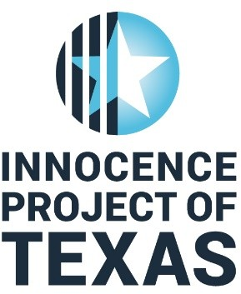

For immediate release: October 29th, 2019

For questions today or day of trial: Jennifer Lorenz, 281-832-2089

Wrongfully Convicted Innocence Project of Texas client

Lydell Grant’s first hearing since being convicted in 2012 set for:
Wed. October 30th 9 a.m.
351st District Court – in Juvenile Justice Center Building at 1200 Congress

First floor, right hand side – Hon. George Powell, Presiding Judge

Lead Attorney, Brittany Lacayo of Lacayo Law Firm in Houston and Mike Ware, Executive Director and Legal Counsel of the Innocence Project of Texas based in Fort Worth will be representing their client Lydell Grant, Wednesday morning, Oct. 30th at 9 a.m. in Judge George Powell’s 351st District Court in Houston.
Wrongfully convicted in 2012, for a murder in 2010 that took place in a nightclub parking lot in the Montrose area of Houston, Lydell Grant, a native Houstonian, was placed in prison in 2012 after he was wrongfully convicted of a stabbing murder in what is a classic case of mistaken eyewitness identification.
At his trial, the prosecutor’s DNA expert mistakenly and inaccurately testified that he could not be excluded as the contributor of the unknown male’s DNA under the victim’s fingernails.
New DNA testing including recent testing done by the Texas Department of Public Safety's lab in Houston absolutely confirmed that the trial testimony in 2012 presented by the prosecutors was inaccurate and false and that Mr. Grant was completely excluded.
Further, in a DPS document, dated June 2, 2019, DPS notified Mr. Grant’s attorneys that there was a match in the CODIS database (National Combined DNA Index database system used to support FBI criminal justice cases) to the DNA found underneath the victim's fingernails. The match was to an offender from Texas with a criminal history who matched the original eyewitness descriptions – who was not Mr. Grant.

The State has agreed that had this new scientific evidence been available at the original trial in 2012, it is reasonably probable that Lydell Grant would not have been convicted.
The State has known about this individual for 5 months. Police reports reveal that since the murder in 2010, the individual identified in the CODIS hit has stabbed yet another person. He is yet to be apprehended.

The defense will be asking the Judge for a new trial and for their client to be found actually innocent. In the meantime, the attorneys are asking the judge to set a reasonable bail while the case continues to be investigated.

For information after the hearing:
Mike Ware, Innocence Project of Texas – 817-992-1132
Brittany Lacayo, BCLLawfirm – 713-504-0506

www.innocencetexas.org
300 Burnett St. #160
Ft. Worth, TX 76102

-30-

